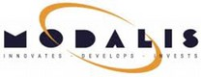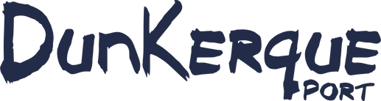

PRESS RELEASE
The MODALIS Group and Dunkerque-Port lay the foundation
stone of the Dunkirk rail-road transhipment terminal
A key investment for European low-carbon logistics

The MODALIS Group and Dunkerque-Port are taking another step towards low-carbon logistics by laying the foundation stone of a rail-road transhipment terminal representing an investment of €25 million. Built in record time, this intermodal site will link Dunkirk to major European industrial centres by rail.

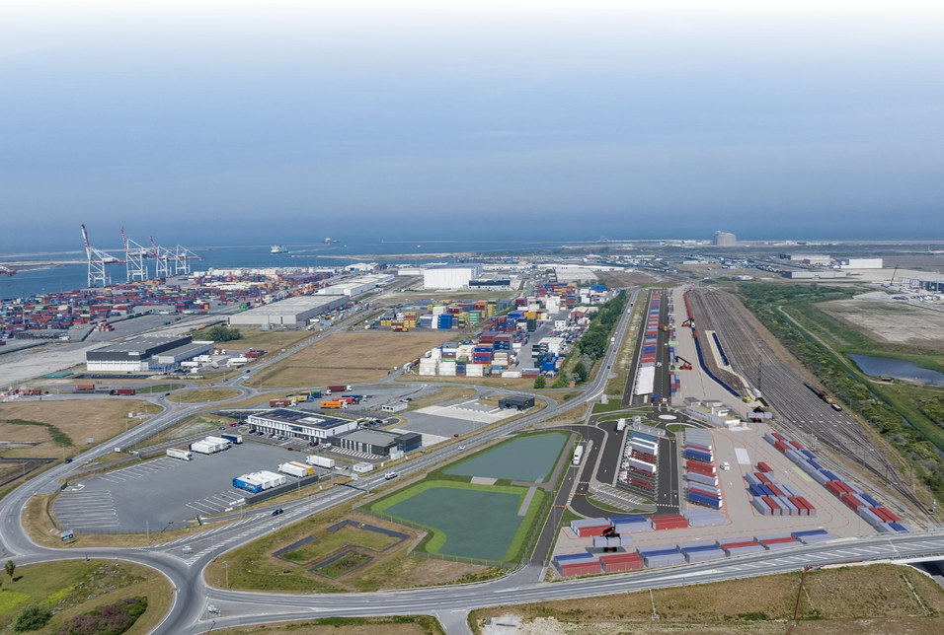
The target is to transfer up to 50,000 transport units per year from road to rail and avoid the emission of 70,000 tonnes of CO₂.
A strategic project for competitiveness and the energy transition in the Hauts-de-France region.

A STRATEGIC INVESTMENT TO ACCELERATE THE DECARBONISATION OF FREIGHT TRANSPORT

The MODALIS Group and Dunkerque-Port are laying the foundation stone of the Western Port rail-road transhipment terminal, a new-generation multimodal platform dedicated to combined rail/roadtransport, designed to ramp up the decarbonisation of continental freight transport. This project is part of a broader context in which France and the European Union are strengthening their energy transition and reindustrialisation policies. With transport accounting for nearly 30% of national CO₂ emissions, developing rail freight has become a priority, supported by the France Logistique 2030 plan, the national strategy for rail freight, and the targets of the European Green Deal, which aims to double the volume of rail freight by 2050.

The terminal will be operational from spring 2026 and enable the rail transport of road semi-trailers and swap bodies (ITUs) over long distances, thereby reducing the use of road-only transport.

Completed in less than two years, this €25 million project, co-funded by the two partners, is the result of collaboration based on trust and a shared vision for sustainable and smart mobility.

Located on 9.6 hectares along the Loon-Plage railway line, at the heart of a dense industrial zone and close to the Great Britain & Ireland Ro-Ro terminals, this new terminal will play a key role in reducing congestion on the roads, cutting CO₂ emissions and optimising the flow of goods, thereby enhancing the economic appeal of the Dunkirk industrial port area and, more broadly, the Hauts-de-France region.

INTERMODAL INFRASTRUCTURE AT THE HEART OF MAJOR EUROPEAN TRANSPORT FLOWS
The terminal aims to transfer road traffic generated by RoRo, logistics and industrial activities in the Dunkirk area and beyond to rail.

Open to all rail operators, the terminal can receive up to four 750 m long freight trains that are capable of transporting the equivalent of 130 to 150 semi-trailers. It also has a large storage area that can accommodate more than 600 transport units (swap bodies or trailers). Ultimately, up to 50,000 ITUs could be taken off the road each year, avoiding nearly 70,000 tonnes of CO₂.

The first regular service will link Dunkirk to Piacenza (Italy), via Lyon, operated by DELTA RAIL, a subsidiary of the MODALIS Group. This rail corridor will connect the industrial basins of northern and southern Europe, with logistical continuity to the United Kingdom thanks to the shipping lines operated by DFDS between Dunkirk, Dover and Rosslare.



MODERN EQUIPMENT WITH A LOW ENVIRONMENTAL IMPACT
The site has the latest-generation handling and traction equipment with a low environmental impact: HVO-powered vehicles, reducing CO₂ emissions by 85%, and electric locomotives for railway manoeuvres.

The site also includes a shared maintenance area that is open to all operators for the maintenance of wagons, swap bodies and semi-trailers, to enhance the range of services available in the region and limit costly empty journeys.

DRIVING THE REGION’S COMPETITIVE EDGE
The terminal’s commissioning is part of Dunkirk’s green reindustrialisation drive, supporting logistics and port developments as well as the region’s decarbonisation trajectory which is being led jointly by public and private stakeholders.

In the short term, the site will generate around fifteen direct jobs and contribute to the training of new technicians in combined transport and railway maintenance.

THE MODALIS INTEGRATED MODEL: THE KEY TO THE LOGISTICS TRANSITION
Founded in 2002, the MODALIS Group has established itself as a major supplier of multimodal equipment and solutions in France and Europe that is committed to decarbonisation. Historically specialising in the leasing and management of intermodal assets (container wagons, swap bodies and chassis), it has gradually developed an integrated model combining engineering, operations, maintenance and infrastructure management. This overall model enables it to control the entire intermodal logistics chain, optimise costs and ensure smooth and secure operations. In addition to its other terminals in Burgundy, Lorraine and Italy, the Dunkirk terminal enables it to connect the major European industrial basins via a network of low-carbon infrastructure.

“Thanks to this project, we are maintaining the smooth flow of land transport services to the port and its surrounding area, while also contributing to European targets for long-distance modal shift. This is a decisive step towards more sustainable and efficient logistics,”
declares Maurice Georges, Chairman of the Management Board of Dunkerque-Port.

“The complementarity between the logistics, port and rail ecosystems is one of the major challenges of decarbonisation. The seaports have an essential role to play in intermodal arbitrations: 80% of goods arrive through them and the choice is then made to use rail, water or road transport. Equipping the ports with modern modal shift infrastructure and efficient handling vehicles will guarantee mass freight demand throughout France. The MODALIS Group is very proud to be able to contribute alongside Dunkerque-Port to this decarbonisation project and strengthen its ecosystem through the use of multimodal terminals,” emphasises Bernard Meï,MODALIS Group Chairman.

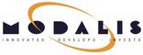
ABOUT THE MODALIS GROUP

MODALIS is a family-owned group founded in 2002 by Bernard Meï, the current Chairman. It supports projects to decarbonise the supply chain through modal shift and new energies. With its established reputation for technical expertise in intermodal transport equipment, the Group’s activities have been enhanced with a view to offering integrated logistics solutions. Innovation and development are the driving forces of the Group, whose mission is to speed up the decarbonisation of freight transport. MODALIS was named ‘Growth Champion’ in 2024 by Les Echos.
For more information, visit: https://www.modalis.com/

ABOUT DUNKERQUE-PORT
Dunkirk is the leading French port complex in cooperation with the other seaports in the Hauts-de-France region. Its ecosystem today incorporates many maritime, logistics and industrial activities with the commitment to achieve carbon neutrality by 2050. More sustainable and more resilient, the port is the no. 1 European energy platform. The development of a Europe-wide benchmark low-carbon industrial zone is the perfect illustration of this. It is based on the decarbonisation of existing industrial processes, the circular economy and green reindustrialisation, of which the Dunkirk region is one of the pioneers. With its ecosystem built around electric mobility, Dunkerque-Port is the heart of the Hauts-de-France electric battery valley. Its platform of innovative solutions combined with the development of container and logistics capacity and the multimodal transport network is creating new prospects for the region. In total, the port generates annual added value of €3.8 billion with a total of 29,000 direct, indirect and resulting jobs. By 2030, the new developments underway in the industrial/port region will have enabled the creation of 20,000 additional jobs.
For further information, visit: www.dunkerque-port.fr

PRESS CONTACT
MODALIS
EVE’VOTREDIRCOM
+33 6 62 46 84 82
servicepresse@votredircom.fr
PRESS RELEASE 2025 PAGE 4

DUNKERQUE-PORT
Anne-Sophie Bataille
+33 6 84 06 19 64
asbataille@portdedunkerque.fr

